1. **Complain**:

Dear Sir,

My name is Khanh Nguyen and I am writing to express my dissatisfaction with ….. Please let me elaborate on exactly my situation.

I have told your staff about the problem….

I am very disappointed with your processing in this problem. .. / You cannot imagine how unhappy I was to discover…

As a solution, I suggest you should exchange a new one for me. If not, I expect a full refund of $1.000 as soon as possible

I await your response and hope this matter can be resolved very soon.

Yours faithfully,

Khanh Nguyen

1. **Advice:**

Dear Mr. Tung,

I am glad to receive your trust when you share with me your problems at (**work)** and want to get my pieces of advice. I hope the following suggestions will be of some to help you.

From my assumption, Here are some reasons why you will not like v-ing….. Firstly…., Secondly…., Finally…

I would like to recommend some jobs that would be suitable for you……

I hope that these suggestions will be of some assistance. I would be happy to offer any additional advice you may require

Yours sincerely,

Khanh Nguyen

1. **Request**:

Dear Mr. Dung

I hope this letter finds you well. I am writing to inquire information about …. Please let me elaborate the situation

There are a few reasons behind my decision, and I thought it would be great to let you know in advance. Firstly…. Secondly,….

I would be grateful if you could tell me know what… I would be interested to know if I….

Please let me know if there is anything specific I should prepare or any other recommendations you might have for my….

I look forward to receiving your response as soon as possible.

Yours sincerely,

Khanh Nguyen

1. **Invitation**:

Dear Mr. Nam,

I have a plan to organize a the … . I am writing to inform you about …. And I would like to take this opportunity to invite you to join …

In a little more detail,….

(Meeting): The meeting will assuredly provide a considerable amount of useful information that largely contributes to our endeavors.

We will be glad and honored to have you participate in the … your presence is of paramount importance to the success of the ….

I look forward to receiving a prompt reply!

1. **Thank You**:

Dear Sir,

I am writing in reference to my/your…And I would like to express

Yours faithfully,

Khanh Nguyen

Dear Sir,

I am writing this letter to thank you for all the support you guys in my interview in yesterday. I appreciate your sharing in working that is very detail and useful.

In my view about the interview, this is a professional interview and has attendance of important departments. I was worried when come in the room. I was became more confident after interviewer introduced about company and everyone who were involved in the interview. I know myself that need to learn and improve so much skill and knowledge to meet all requirements that your company expect. I am thinking that your company has a very good environment for working and development myself. It will be amazing if I have a chance to use my talent to contribute for the success of your company with my best.

Once again, I thank you for your support in the memorable interview.

I look forward to receiving good news from you

Yours faithfully,

Khanh Nguyen

1. Apologize

Dear Mr.Kven

I am writing to apologize for ….. Please let me elaborate on my situation.

I am sincerely sorry for not being able to … I am aware of the importance of the.. but, unfortunately, my absence was unavoidable.

Please accept my sincerest apologies for that issue..

Yours sincerely,

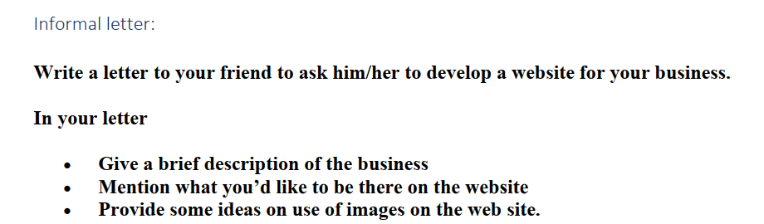 Dear, Mr.Dung,

I hope this letter finds you well. I am writing to express my wishes that is to discuss with you an exciting opportunity that I believe will greatly benefit both of us. Let me elaborate on exactly my situation.

I have recently started a new business project, and I need a professional website to establish a strong online presence. As I know that you have good skills in web development. I could not think of anyone better suitable for this task than you.

Let me give you a brief overview of my business. I launched a small be growing online store specializing in handmade jewelry. I need to build a website to show all our products on that. It has become important for us to expand our approach and tap into the digital marketplace. Regarding the website, I am imagining it to be an engaging and user-friendly platform that reflects the quality of our brand.

I would like to describe more about the use of images on the website. Since our business revolves around visual aesthetics, high quality is necessary in showing our jewelry in the best possible light. I suggest using professional product photography to capture the complicated detail.

Please let me know if you are interested in taking on this project. I am confident that with your skills, we can create a website that effectively represents our brand and captivates our target audience.

Looking forward to your positive response.

Yours sincerely,

Khanh Nguyen

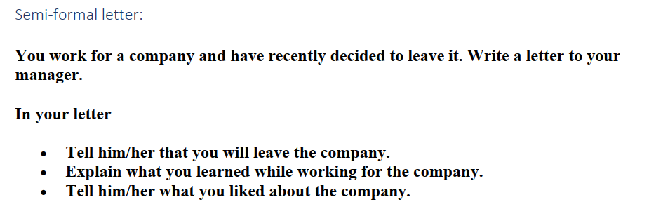

Dear Mr.Long,

I hope this letter finds you well. I am writing to inform you that I made the difficult decision to resign my position at our company. Please let me elaborate on exactly my situation.

After careful consideration and reflection. I have my conclusion that it is time for me to explore new opportunities and challenges in my career path. I believe that my time at our company has equipped me with a strong foundation. It enables me to take on new projects with confidence. I want to apply my experience that I learned at our company to a new environment. I would like to express my deepest appreciation for the learning opportunities that our company has offered me. The training programs, workshops, and consultative skills have contributed significantly to my growth and have equipped me with the necessary tools to develop myself.

In addition, I really appreciate the company's processing workflow. It is very professional and extremely flexible. Especially with the manager group, who are always willing to support all members in the project to complete their tasks on time with the best qualities. From my perspective, after over 10 years working for our company, I always think that this is my second home with plenty of love and close-knit memberships. However, now I am very sorry to leave it to try my talent in new challenges, new environments.

In conclusion, I would like to say thank you for your understanding and support. Please let me know if there is anything I need to do to hand over my tasks as possible. I wish you and the entire team at the company continued success.

Yours sincerely,

Khanh Nguyen